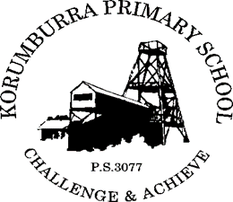

Korumburra Primary School
ANTI-HARASSMENT POLICY

Definition:

- Harassment is the exertion of power by one person over another – often presenting as bullyish behaviour – which makes another person feel embarrassed, offended, upset, devalued, degraded, afraid, frustrated or angry. It is unwelcome, unreciprocated, uninvited and usually repeated. It is behaviour that breaches proper and professional conduct.

Rationale:

- Harassment in any form is unacceptable. As educators, we have a responsibility to provide teaching and learning environments that are free from harassment, and that encourage students to develop attitudes and skills that discourage, challenge and report harassment in all forms.

Aims:

- To provide a fair and supportive environment free from all forms of harassment, that promotes personal respect, as well as providing physical and emotional safety for all.

- All staff will be made aware of the legislative requirements relating to harassment.
- All staff will complete the Department of Education online Workplace Discrimination & Sexual Harassment training.
- Professional development relating to harassment will be provided for all staff, who in turn will model and practice appropriate behaviour.
- Staff, students and members of the school community will be familiar with the school’s approach to harassment and will be provided with information relating to their rights and responsibilities.
- School-level protocols for resolving issues or complaints will be developed and well publicised.
- Staff members will not allow themselves or their colleagues to be subjected to harassment from parents or students – all such issues must be immediately reported to the principal.
- Unresolved school-level issues may be referred by the principal, or the parties involved, to the appropriate authorities.
- Our school is a “No Put Down Zone” and we reward students who display exemplary behaviour.
- Harassment by students will attract consequences consistent with our Student Code of Conduct.
- All claims of harassment will be treated confidentially, documented, and promptly and constructively addressed.
- The rights and sensitivities of all individuals will be protected.
- Curriculum content will analyse the effects of harassment and assist students to develop attitudes and skills that discourage, challenge, counter-act and report harassing practices.

Evaluation:

This policy will be reviewed as part of the school’s three-year review cycle or earlier as required.

This policy was last ratified by School Council in 2019

