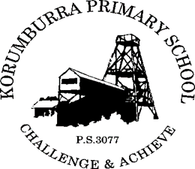

Korumburra Primary School
CONTINUOUS IMPROVEMENT POLICY

Rationale:

- Our school seeks to provide the best education it can for our students. As such, we subscribe and commit to a workplace of continuous and sustained self-improvement.

Aims:
- To establish a workplace where continuous improvement is embedded in the school’s ethos and culture.
- To provide the best education that we can for our students by constantly and strategically identifying and implementing improvements in all facets of our school.

Implementation:

- Continuous improvement is as much about attitude as it is about process.
- All staff at our school have demonstrated a commitment to continuous improvement, and understand that a high performing school is to the benefit of everybody.
- Our school values relies upon robust, authentic and valid performance data.
- Discussions relating to continuous improvement data will focus on opportunities for development and enhancement as opposed to shortcomings or deficits.
- A Leadership Team will analyse whole school data and develop strategic plans to improve performance in identified areas of need.
- In doing so, the Leadership Team will set high and realistic expectations, and clearly articulate expected levels of performance by students and staff.
- Individual staff members will, in consultation with others, analyse their own performance related data and propose performance and development plans to the principal for consideration, to improve their own performance levels in targeted areas.
- Targeted whole school and personal professional development will provide significant support in the achievement of identified improvement goals.
- Mentors will be identified for all staff members, and staff with expertise in specific fields will be identified and made available to all.
- Achievement progress will be closely monitored and constructive and precise feedback based on data will feature prominently.
- Achievements will be publicly and enthusiastically celebrated, and will set benchmarks for new improvements.
- The school has a rigorous Performance and Development Culture.

Evaluation:

This policy will be reviewed as part of the school’s three-year review cycle or earlier as
required.

This policy was last ratified by School Council in 2019

